## Mitosis and the Cell Cycle

## – How a Single Cell Develops into the Trillions of Cells in a Human Body[1]

**Cells, Chromosomes and Genes**

Every person started as a single cell – a fertilized egg.

**1a.** How many cells do you think there are in your body?

**1b.** How do you think a single cell developed into the trillions of cells in your body?

Before you learn how new cells are made, we need to briefly review chromosomes and genes.

|  |  |
| --- | --- |
| * Each **chromosome** contains a long molecule of DNA. * Each **DNA** molecule contains many genes. * A **gene** is a segment of a DNA molecule that gives the instructions for making a protein. Many of these proteins are needed for normal cell structure and function.   **2.** Explain why each cell needs to have a complete set of chromosomes. Include genes and proteins in your answer. |  |

|  |  |
| --- | --- |
| This figure summarizes how a cell divides into two daughter cells. Each daughter cell has a complete set of chromosomes. |  |

**3.** Suppose that, after the cell division shown in this figure, each daughter cell is preparing to divide again. In the second column of the table, describe two things that each daughter cell needs to do to be ready for cell division.

|  |  |
| --- | --- |
|  | How the daughter cell prepares for cell division |
| Hint 1: Remember that each cell needs a complete set of chromosomes. |  |
| Hint 2: What else would the cell need to do to be big enough to divide? |  |

**The Cell Cycle – How One Cell Becomes Two Cells**

This figure shows how one cell becomes two daughter cells.

**4.** The cell cycle begins with a single cell and produces two daughter cells; each daughter cell can repeat the cell cycle. Circle the cell in the figure that represents both a daughter cell that has been produced by the cell cycle and a cell that is beginning the cell cycle. Explain why the cell is smallest at this time in the cell cycle.

**5a.** Use 2x to label the arrow(s) when the amount of DNA doubles.

**5b.** Use ½ to label the arrow(s) when the amount of DNA in the cell is halved.

**6.** Complete this table to explain why specific phases of the cell cycle are required for successful cell division.

|  |  |
| --- | --- |
| What would go wrong if the cell cycle occurred without the S phase? |  |
| What would go wrong if the cell cycle occurred without mitosis? |  |
| What would go wrong if the cell cycle occurred without cytokinesis? |  |

**Mitosis – How Each Daughter Cell Gets a Complete Set of Chromosomes**

**7a.** The figure below shows mitosis and cytokinesis for a cell that has one pair of chromosomes. Label the sister chromatids and the centromere in one of the chromosomes.

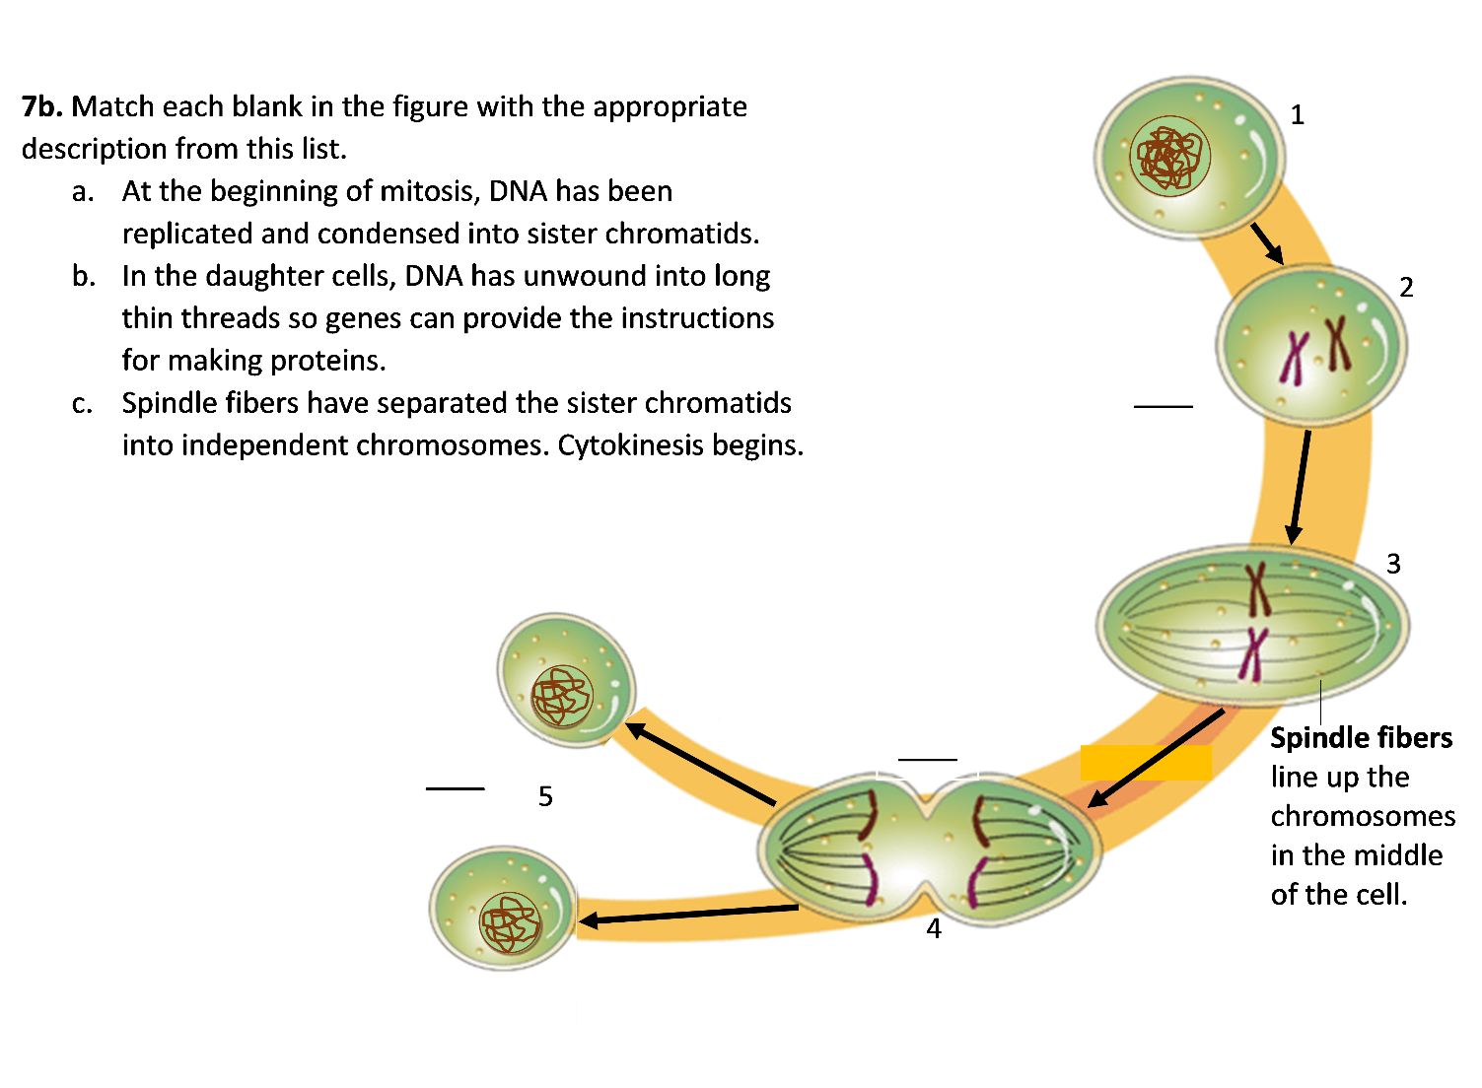

**7c.** The chromosomes in the second and third drawings in this figure have sister chromatids. Explain why the chromosomes in the fourth drawing do not have sister chromatids.

**7d.** Show a complete cell cycle in the figure; use arrows to show that the G1, S and G2 phases would prepare a daughter cell for mitosis.

**8.** Suppose that the very long thin chromosomes observed during interphase did *not* condense into shorter fatter sister chromatids at the beginning of mitosis. What problems could occur during mitosis if the chromosomes had a long thin shape?

**9.** This figure shows six stages of cell division for a cell that has two pairs of chromosomes, but these stages are not shown in the correct sequence.

* Draw arrows to show the correct sequence for these stages of cell division.
* Use an * to mark the arrow which shows when sister chromatids separate to form individual chromosomes.
* Label the drawing that shows the beginning of cytokinesis.

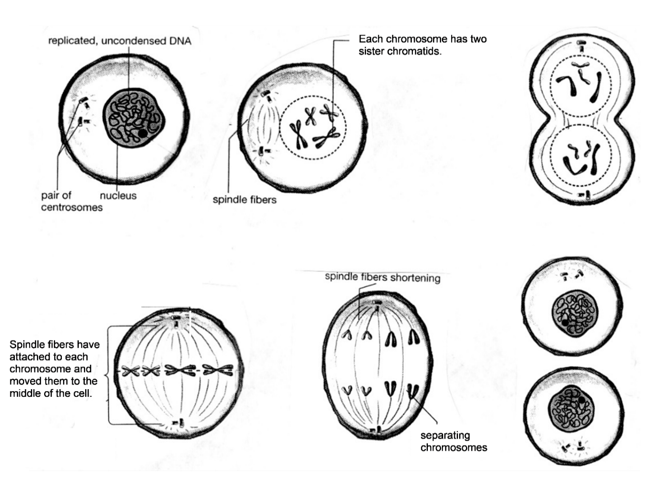

**Genes and Human Characteristics**

To learn more about mitosis, you will use model chromosomes that are labeled with specific human genes. The table below describes two of these genes.

Different versions of the same gene are called **alleles**. Different alleles give the instructions for making different versions of a protein.

|  |  |  |
| --- | --- | --- |
| **Allele** | **→** | **Protein** |
| **A** | **→** | Functional enzyme that can make melanin, a pigment molecule that gives color to human skin and hair |
| **a** | **→** | Nonfunctional enzyme that cannot make melanin |
|  |  |  |
| **S** | **→** | Normal hemoglobin |
| **s** | **→** | Sickle cell hemoglobin |

**10a.** In this table:

* Circle each symbol that represents part of a DNA molecule.
* Underline each word that is the name of a protein.

**10b.** What do the arrows in the table represent?

|  |  |
| --- | --- |
| Each human cell has 23 pairs of homologous chromosomes. In a pair of **homologous chromosomes**, both chromosomes have the same genes in the same locations. A gene may have different alleles in the two homologous chromosomes (e.g. **Aa**) or a gene may have the same allele in both chromosomes (e.g. **SS**). This figure shows a pair of homologous chromosomes in a cell at the beginning of mitosis. |  |

**11a.** Label two sister chromatids.

**11b.** Explain why the sister chromatids in each chromosome always have the same alleles for each gene.

All of a person’s body cells have the same combination of alleles; this combination of alleles is the person’s **genotype**. The person’s observable characteristics are called the **phenotype**. This table shows how different genotypes provide the instructions to make different versions of a protein, and these different versions of the protein result in different phenotypes.

|  |  |  |  |  |
| --- | --- | --- | --- | --- |
| **Genotype** | **→** | **Protein** | **→** | **Phenotype** (characteristics) |
| **AA** or **Aa** | **→** | Enough functional enzyme to make melanin in skin and hair | **→** | Normal skin and hair color |
| **aa** | **→** | Nonfunctional enzyme that cannot make melanin | **→** | Very pale skin and hair color; albino |
|  | | | | |
| **SS** or **Ss** | **→** | Enough normal hemoglobin to prevent sickle cell anemia | **→** | Normal red blood cells; no sickle cell anemia |
| **ss** | **→** | Sickle cell hemoglobin, which can cause red blood cells to become sickle shaped | **→** | Sickle shaped red blood cells can block blood flow in small blood vessels, causing pain and organ damage; sickle cell anemia |

**12.** Explain why a person with the **aa** genotype has very pale skin and hair color. Include the words enzyme and melanin in your explanation.

**13.** Suppose that Amanda’s cells have the pair of homologous chromosomes shown in the drawing at the top of the page.

* What is Amanda’s genotype? **aass** ___ **AaSS** ___ **AASS** ___
* Is Amanda an albino? yes ___ no ___
* Does Amanda have sickle cell anemia? yes ___ no ___

**Modeling Mitosis with One Pair of Homologous Chromosomes**

Complete each step in this modeling procedure and check the box.

|  |  |
| --- | --- |
| * Get a pair of model homologous chromosomes, one with the **a** and **s** alleles and the other with the **A** and **S** alleles. Both model chromosomes should be the same color, but one model chromosome will have a stripe on both sister chromatids to indicate | C:\Users\Ingrid\AppData\Local\Microsoft\Windows\Temporary Internet Files\Content.Word\figure mitosis 1.5.png |

that, although these two homologous chromosomes have the same genes, they have different

alleles for many of the genes.

* Line up the model chromosomes as shown in the figure below. Use string or chalk to represent the cell membrane that surrounds the cell.

* Sit across from your partner and use your arms to represent the spindle fibers that move the chromosomes. Demonstrate how the sister chromatids of each chromosome are separated into two separate chromosomes which go to opposite ends of the cell.

* Now the cell is ready for cytokinesis which will produce two daughter cells, each with a complete set of chromosomes. Use string or chalk to show the cell membranes after cytokinesis.
* Prepare to model mitosis again by putting the sister chromatids of your model chromosomes back together, as shown above. (This does *not* correspond to any biological process – it is a substitute for the biological process of replicating the DNA in each chromosome.)

**14.** Model mitosis again and record the results in the figure below. Draw and label the chromosomes in the oval and in the daughter cells.



**15a.** The original cell had the genetic makeup **AaSs**. What is the genetic makeup of each daughter cell?

**15b.** Does each daughter cell have the same genetic makeup as the original cell?

**Multiple Pairs of Homologous Chromosomes**

Each human cell has 23 pairs of homologous chromosomes. Each of these pairs of homologous chromosomes has its own unique set of genes. For example:

* Human chromosome 11 has the genes that can result in albinism and sickle cell anemia, as well as more than 1000 other genes.
* Human chromosome 12 has different genes, including a gene that can result in alcohol intolerance. This table shows the effects of the **L** and **l** alleles of this gene.

|  |  |  |  |  |
| --- | --- | --- | --- | --- |
| **Genotype** | **→** | **Protein** | **→** | **Phenotype** (characteristics) |
| **LL** or **Ll** | **→** | Nonfunctional enzyme that cannot dispose of harmful molecules produced by the metabolism of alcohol | **→** | Alcohol intolerance (skin flush and discomfort after drinking alcohol) |
| **ll** | **→** | Functional enzyme that disposes of harmful molecules produced by alcohol metabolism | **→** | Not alcohol intolerant (no skin flush or discomfort after drinking alcohol) |

Modeling Mitosis with Two Pairs of Homologous Chromosomes

* Get a second pair of model homologous chromosomes, one with the **L** allele and the other with the **l** allele. Model mitosis for a cell with two pairs of homologous chromosomes.

**16.** Record the results of your modeling in this figure.

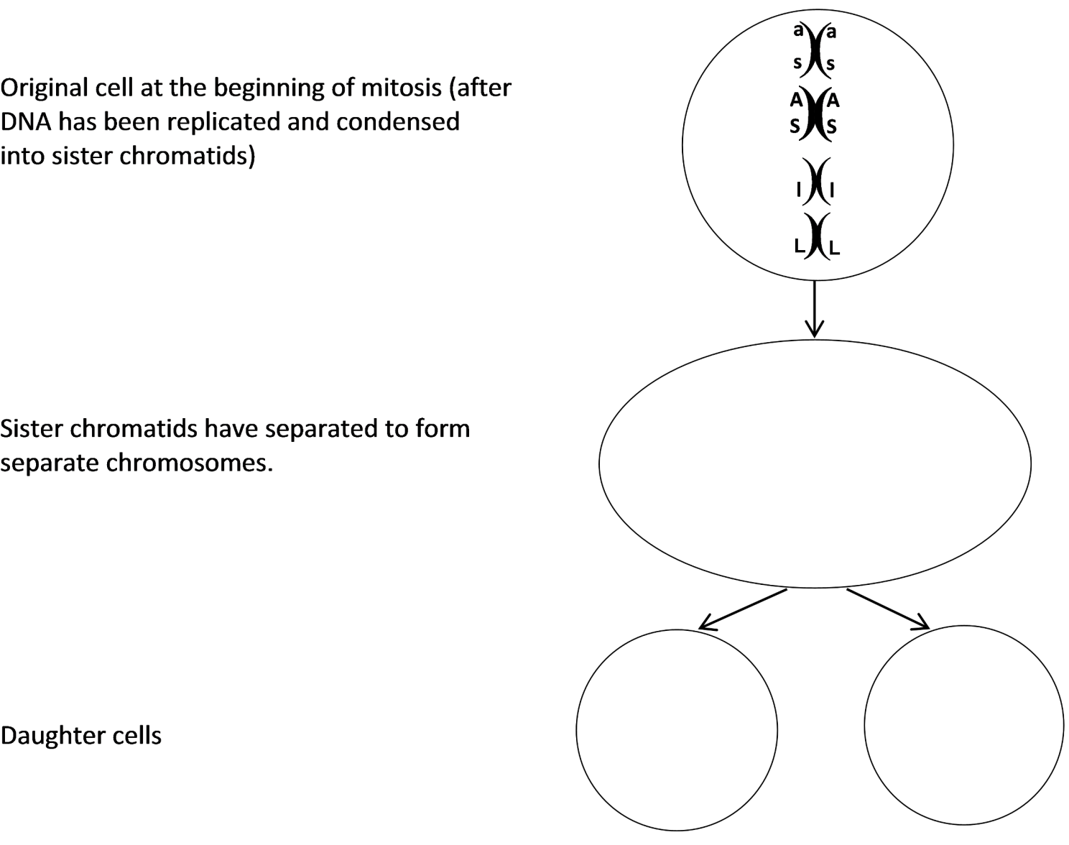

**17a.** The original cell had the genetic makeup **AaSsLl**. What is the genetic makeup of each daughter cell?

**17b.** Does each daughter cell have the same genetic makeup as the original cell?

**How Repeated Cell Division Can Make Trillions of Cells**

Each of us began as a single cell which divided into two daughter cells. How can multiple repetitions of one cell dividing into two cells produce the trillions of cells in a human body? To understand, answer the questions below.

**18a.** Complete this table to show the number of cells an embryo would have if every cell divided each day, so the number of cells doubled each day.

|  |  |  |  |  |  |  |  |  |  |  |  |
| --- | --- | --- | --- | --- | --- | --- | --- | --- | --- | --- | --- |
| Day | 1 | 2 | 3 | 4 | 5 | 6 | 7 | 8 | 9 | 10 | 11 |
| # Cells | 1 | 2 | 4 |  |  |  |  |  |  |  |  |

**18b.** On day 2 there was only one more cell than on day 1. On day 6 there were ______ more cells than on the previous day. On day 11 there were _______ more cells than on the previous day.

**18c.** Explain why more cells were added on day 11 than on any previous day.

**19a.** If each cell divides each day, then the number of cells will double each day. Every 10 days, the number of cells will be multiplied by 210, which is approximately 1000. An embryo begins as a single cell. If each cell divided each day for 20 days, approximately how many cells would there be?

**19b.** Approximately how many cells would there be after 40 days of cell division?

As an embryo grows, the number of cells available to divide increases, so cell division can add more and more cells each day. This explains how cell division can produce more than a trillion cells in a newborn baby, starting from a single cell just nine months earlier!

**20.** To summarize what you have learned, explain how a single cell developed into the trillions of genetically identical cells in your body. A complete answer will include the following terms:

cell cycle, DNA replication, mitosis, spindle fibers, sister chromatids, chromosomes, cytokinesis, daughter cell, genes.

(Cross off each of these terms after you have included it in your answer.)

**21.** Even in a fully grown adult, some cells continue to divide. Why is cell division useful in an adult who is no longer growing? (Hint: Think about what happens when you have an injury that scrapes off some of your skin.)

1. By Drs. Ingrid Waldron, Jennifer Doherty, R. Scott Poethig, and Lori Spindler, Department of Biology, University of Pennsylvania, © 2020. This Student Handout and Teacher Preparation Notes with instructions for making the model chromosomes, instructional suggestions, and background information are available at <http://serendipstudio.org/exchange/waldron/mitosis>.